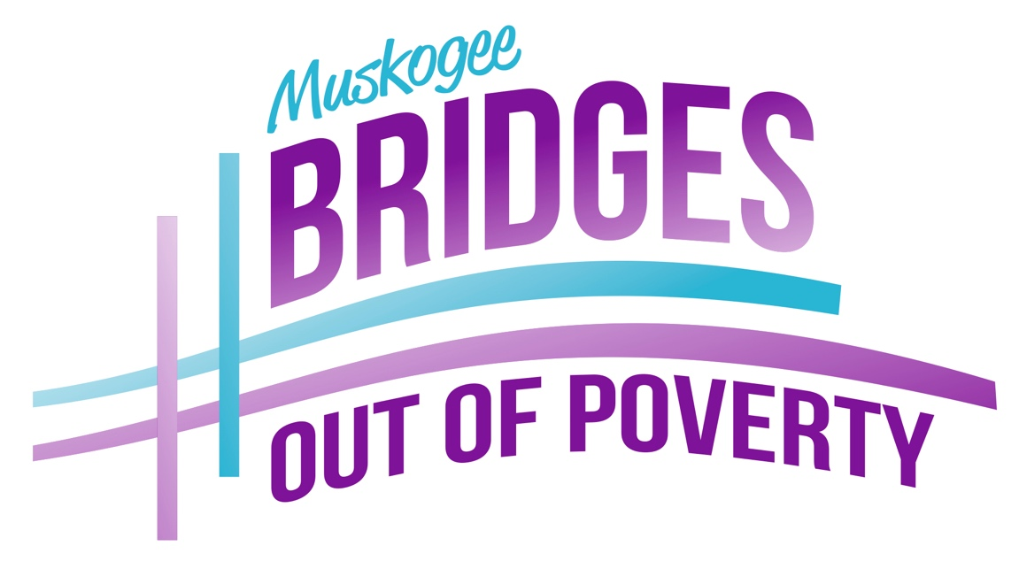

A comprehensive community wide initiative to reduce poverty

Funded by a grant from the City of Muskogee Foundation
and general donations from the public

Empowering low-income families
​to radically change their lives by
discovering and overcoming barriers
to success.

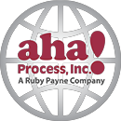
About aha! Process
aha! Process is an award-winning training and publishing company providing workshops, publications, and consulting services to help improve lives and build sustainable success in communities, schools, and higher education. We do this by creating an understanding of the dynamics that cause and maintain poverty from the individual to systems level.
Poverty, middle class, and wealth are about an abundance or lack of resources. Our work helps individuals, businesses, students, and communities build resources for a more successful, sustainable future. www.ahaprocess.com
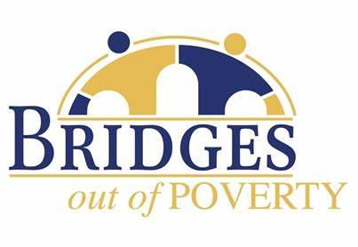
The Bridges Out of Poverty model is currently used in 35 states and 7 countries. There are currently 33 communities across the world that have established Communities of Practice.
All sectors of a community must collaborate and the communication between members looks like this:
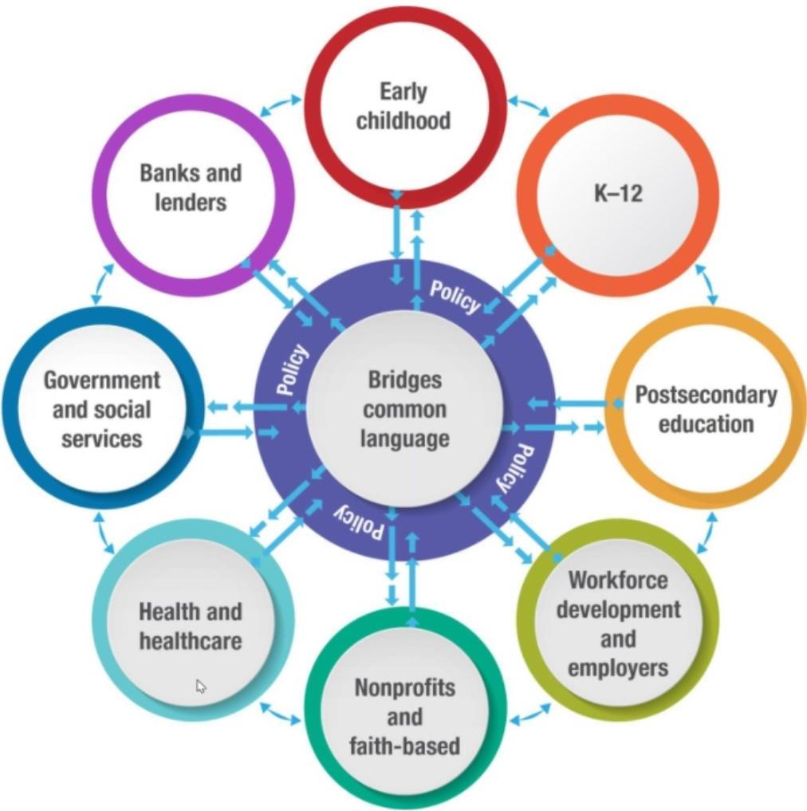
About Muskogee Bridges Out of Poverty
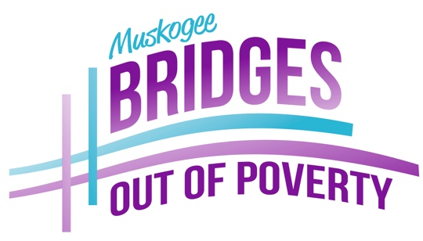
Muskogee Bridges Out of Poverty focuses on empowering those in poverty to investigate the barriers that keep people from getting ahead and educates the entire community on the complexities of poverty. The initiative seeks to empower those in poverty to identify and use the abilities they already have to solve their own problems through analyzing their realities. This Community of Practice brings together community leaders, faith communities, employers, community organizations, social service agencies, and individuals address and reduce poverty in a comprehensive way.

Graduating over 400 families in 10 years, Muskogee’s Bridges program has become a national model for success in moving the needle on generational poverty.

Muskogee was named the
National Bridges Out of Poverty Community of the Year!
Vision
Reducing the social costs of poverty, strengthening the workforce, and building a more prosperous and sustainable community are goals on which most communities agree. aha! Process’s Bridges Out of Poverty initiative provides a family with concepts, workshops, and products to help employers, community organizations, social service agencies, and individuals address and reduce poverty in a comprehensive way. Bridges brings people from all sectors and economic classes together to improve job retention rates, build resources, improve outcomes, and support those who are moving out of poverty.
Generational Poverty is defined as a family having lived in poverty for at least two generations. By providing a way for the parents of these children to build their resources and become self-sufficient we can greatly impact the generational poverty cycle.
Community Need
The percent of population living below 100% of the Federal Poverty Level in Muskogee County is 23%, as reported by CHNA. This is significantly higher than the state rate of 15%, and the national rate of 13%. It is also noteworthy that 86% of public-school students are eligible for Free/Reduced Price lunch. Median household income in Muskogee County is $38,502, compared to the state median income of $45,339. There is a high level of distress in related to poverty, crime, health, single parenting, multiple disparities in the arenas of education, healthcare, employment and housing, as well.
Outcomes
The outcome measurements indicate how resources and stability increase for graduates.
The Bridges Out of Poverty support program helps communities:
- Move individuals from poverty to self-sufficiency
- Reduce social costs related to crime, poor health, and social services
- Strengthen educational attainment and job skills
- Enhance economic development
- Improve on-the-job productivity
- Revitalize neighborhoods
- Build sustainable communities where everyone can live well
In 10 years:

- 438 Getting Ahead graduates (families)
- 1500 Business and community leaders educated
- 575 Children have seen their parents “Get Ahead”

Graduates report that since taking the Getting Ahead Class:

- 81% have furthered their education
- 85% have increased their income
- 88% have decreased their debt
- 76% have opened a bank account
- 92% have an increased level of hope
- 73% are now SELF-SUFFICIENT (meaning off social services)

Social Return On Investment

The social return on investment is much more than just numbers. When people are trained and supported to get and keep better jobs, they reduce their family’s need for government assistance, they have better chances of owning their own homes and they encourage their children to become educated—all of which benefit our society. When people feel they have options other than crime, the costs of law enforcement and community safety, court, and probation are also significantly reduced.

Addressing generational poverty has lasting effects on our community. Poverty stunts an individual’s potential and growth by fostering illness, less education and skills, fewer legitimate opportunities to get ahead in life, greater anxiety and mental stress, and so on. These, in turn, result in children being less economically productive as adults.
Getting Ahead in a Just Getting by World Curriculum
Getting Ahead classes help our community members in poverty move from poverty to self-sufficiency. It is a proven curriculum currently being used in 46 states and 5 countries with over 80,000 graduates.
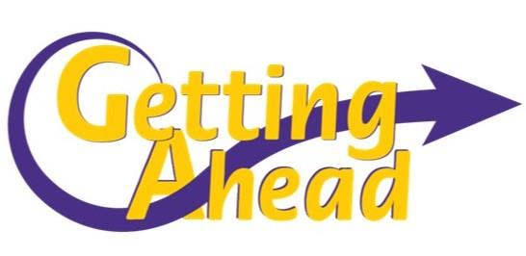
Getting Ahead in a Just-Gettin’-By World is a 20-week curriculum, offered every spring and fall. They meet on Tuesday nights from 5:30 pm – 8:30pm in at St. Paul Church. There are two classes divided up into English speaking and Spanish speaking, each having a maximum of 12 Investigators (members). Qualifications for class participation require families to be below 200% of the federal poverty guidelines with a Muskogee address. They must also show in their interview that they are willing to do whatever it takes to change.

The program offers a healthy meal for the whole family prior to the classes. Applying a two generational approach, the children attend childcare that focuses on The R Rules (Respect, Rigor, Relationships, etc.) and Khan Academy curriculum. Students have increased at least 2 grade levels in math and grammar every semester.

The workbook takes the class step by step through a discovery of themselves, how they got where they are and what it takes to build the life they want. There is a paid facilitator in the room to ensure all investigators share in the discussions in this group taught class.

The classes are asked to “investigate” their world, hence the term Investigators, and identify the societal barriers that are keeping them in generational poverty and give them a strategy to overcome them. They investigate the realities of conditions in their community and its impact, the hidden rules of economic classes, how to build resources and make connections, and ways to deal with change and create stability in their lives. They learn about debt-to-income ratios, building social capital, establishing smart goals, and finally they create their own future story.

Community leaders, such as the Mayor, the School Superintendent, Police Department, DHS, and Housing Authority serve as guest speakers to promote open discussion with these policy makers about the issues this “under-resourced” population is dealing with in regard to their perspective industries. This provides an opportunity to increase their social capital by building relationships they would not otherwise have, along with a “social” evening where local businesspeople are invited to join the classes for dinner. This social networking event has bridged the gap between the economic classes in Muskogee.

The investigators are paid a $25 stipend for each class in the form of Wal-Mart gift cards. In return, we receive the list of barriers they have identified in their investigations and can address the issues as a community. This all culminates in a graduation ceremony in May and December to celebrate their accomplishments and future.
Staying Ahead Curriculum
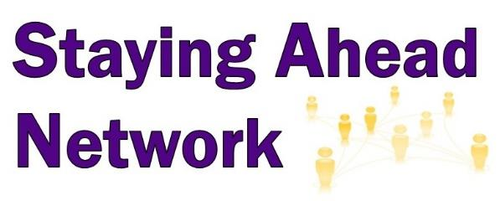
It’s crucial to provide long-term support while graduates are building resources and transitioning out of poverty. Offering additional classes keep Investigators involved in Bridges for up to two years.

Money Matters 101/Financial Peace University (offered in English and Spanish)
Funded by 6 local banks, this class covers everything from how to read your paycheck to tracking spending, creating a budget, acquiring and repairing credit reports, avoiding financial predators, and the importance of involving the whole family. The class culminates in Dave Ramsey’s Financial Peace University which focuses on having an emergency fund, paying off debt, benefits of insurance, how to purchase a home, and investing.

Boundaries Class
Based on the book by Townsend and Cloud, this curriculum focuses on creating healthy boundaries, like when to take responsibility, the difference between hurt and harm, learning when to say “yes”, and which behaviors have consequences.

Positive Parenting Class (Offered in English and Spanish)
Based on the Nurturing Parenting curriculum this is a family-centered trauma informed class featuring activities to foster positive parenting skills with nurturing behaviors, promote healthy physical and emotional development, and teach appropriate role and developmental expectations.

Invitation to Change Class
This class is for family and friends of those struggling with substance use issues. You will learn to better understand their behavior and communicate with them while taking care of yourself in the process.

ESL (English as a Second Language) Class
Provides basic English Instruction to non-native speaking graduates with a focus on career readiness and advancement, prep for High School Equivalency or GED, and Naturalization Test. Participants advance at their own pace through four levels of classes that teach writing, reading, listening, speaking, and pronunciation.
Additional Services
Dental and Vision Services
In their community assessment, investigators have often identified poor dental health as a barrier to success and are now offered access to free dental services. Four local dentists volunteer their time to run the clinic that includes basic services, oral surgery, and dentures. Improved self-confidence when smiling at a job interview can change someone’s life. Graduates can apply for free eye exams with free glasses which helps when applying for a job or going back to school.

Micro-Loans
Investigators have access to a micro-loan program when “life happens”. Small loans with zero percent interest can prevent someone from taking a “payday” loan when a situation arises.

Community Resources List
A landing page on our website provides resource information to citizens in poverty. Knowing where to get help in our community is key for this segment of society. This page provides contact information for the local food pantries, health care, help with utility bills, transportation, shelter, and crisis/counseling lines.

Attorney Services
The Bridges Attorney provides free legal services to Getting Ahead Investigators and Graduates. Focusing on civil cases only, this attorney has helped with custody, landlord issues, warrants for failure to pay, Power of Attorney, protective orders, immigration, and wills. This service helps graduates navigate the legal system with a trained professional at their side.

Car Donation Program
Donating a used car has two benefits, the donor gets a tax write off and the graduate gets the barrier of transportation removed. Graduates can apply for the vehicle after they have taken the Money Matters 101 class, this ensures that they have the knowledge we deem necessary about insurance, and the importance of paying off the debt. A local bank will give them a car loan and they must keep insurance on the vehicle. After the car is paid off, the bank will report positively to their credit.

Bridges Out of Poverty Community Workshops
Community Workshops provide community leaders and employers with the understanding of the complexities of poverty, as well as how they can play a key role in being a part of the solution. It creates awareness of the consequences of the policies they may be making, and it generates Resource Partners for investigators. Awareness is the first step in creating positive change for the under-resourced. As a result of these workshops, attendees have altered their businesses policies that seem to punish their under-resourced employees for things beyond their control, some have offered job opportunities to investigators, and others find ways to use their talents and knowledge to help the program.
This 3-hour training includes an overview of the Bridges Model as it relates to the Individual, Institutions, and the Community. The Bridges constructs include Social Cognitive Theory, Mental Models of Economic Class, the Causes of Poverty, Hidden Rule Among Economic Classes, the Eleven Resources, Registers of Language, Household Dynamics, Theory of Change, Influencing Policy and Procedure, and Staying Ahead Support
These trainings are available for employers who would like their staff to be introduced to these Bridges concepts and strategies that can be implemented within their respective organization. Muskogee Bridges Director, Treasure McKenzie, is a Certified Bridges Trainer and a National aha! Process Consultant.
To schedule a training, please contact Treasure McKenzie at treasure@muskogeebridges.org.
Board of Directors

Dan Morris
Advantage Controls
Joy Sloan
Green Country Behavioral Health
Tom Martindale
Muskogee County Community Sentencing
Renee Fredrick
Mabrey Bank
James Poffel
Muskogee Police Department
Blake Farris
Muskogee Housing Authority
Kim Williams
OG&E
Donna Pillars
Muskogee Public Schools
Linda Ingram – Graduate
Green Country Behavioral Health
Jennifer Guilliam – Graduate
Home 2 Suites
Graciela Perez – Graduate
Muskogee County Head Start
Emery Mason
St. Paul United Methodist
Marlon Coleman
Mayor, City of Muskogee
Wren Stratton
City of Muskogee Foundation

Staff

Treasure McKenzie
Director
Shenia McNac
Success Coach
Rosa Stafford
Hispanic Success Coach
Nancy Gaden
Chief Financial Officer
Samantha Cook
Childcare Director
13 Childcare Workers

Financial Support
We are grateful to the following organizations who have provided funding to support this project over the past five years:
Advantage Controls
American Bank of Oklahoma
Armstrong Bank
Arvest Bank
BancFirst
Bank of Oklahoma
Ekklesia Church
Firstar Bank
Foundation Management Inc.
Green Country Behavioral Health
Hammons & Price Attys at Law
Interstate Properties, Inc.
KIBOIS Community Action
Mabrey Bank
Martin Designs
Muskogee Area Human Resource Assoc.
Muskogee Housing Authority
Muskogee Medical Foundation
Muskogee Soroptimist
Muskogee Youth Agency Council
Rotary Club of Muskogee
Squeaky Clean Janitorial (a GA Grad owned business)
Sonshine Daycare
St. Paul United Methodist Church
Valourec
Westside Church of Christ

For More Information
1503 W. Broadway
Muskogee, OK 74401
918-840-5331
www.muskogeebridgesoutofpoverty.org

